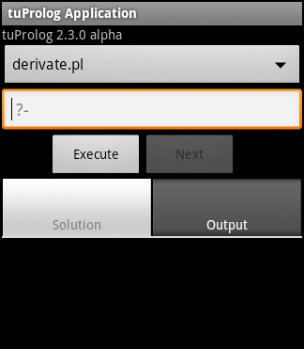
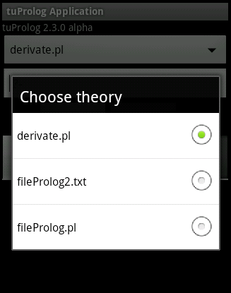
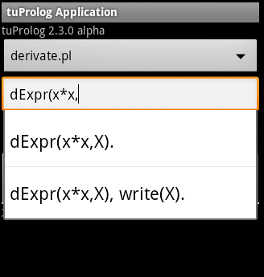
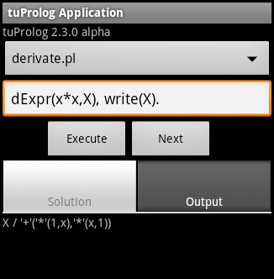
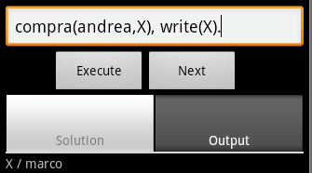
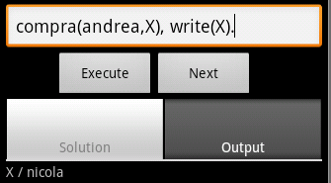
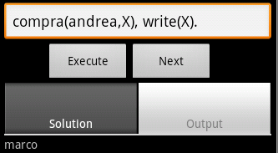
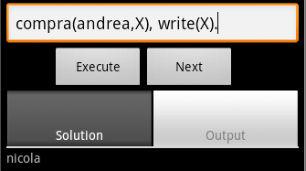
tuProlog for Android (2.4.3 RC)
Installation
The installation process remains the same as older versions:
- Set your device to allow applications from unknown sources. You do so by setting the proper option in Settings > Applications > Unknown Sources (Android version 2.3) or in Security > Unknown Sources (Android version 4.0+).
- Copy the .apk file of tuProlog in the device SDcard: if the device is connected to your computer via USB cable, we suggest that you put the .apk file in the download subfolder.
You can also directly download the .apk in your phone from the download page: http://alice.unibo.it/xwiki/bin/view/Tuprolog/Download

- Click the .apk file to start the installation. Please allow the application to access the required data. At the end of installation, a new tuProlog icon will appear in the installed applications:

0. Loading Screen
When you open the application a loading screen will show, automatically the Home Activity will be loaded in few seconds.
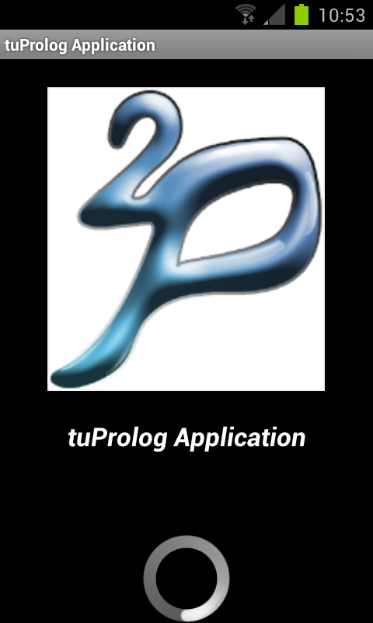
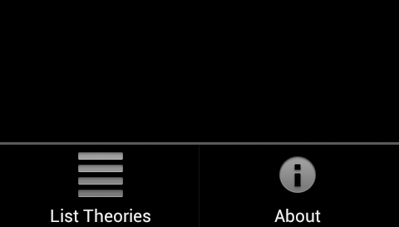
1. Home Activity
The first Activity that will open after the load screen looks as follows:
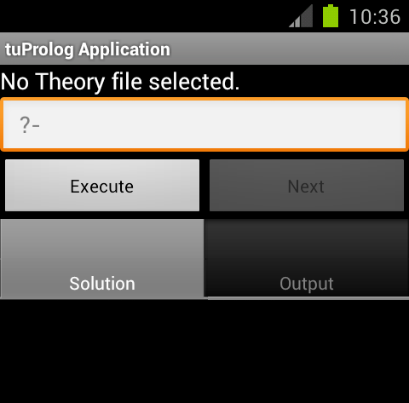
The first TextView shows the Theory loaded in the tuProlog engine from your Theories Database. When you open your application there won't be any Theory selected.
To select a Theory you must use the Theories Database activity, you can navigate to it pressing the Menu button of your phone and clicking on “List Theories”.
(chapter 5 for more details about this activity)

In this menu you will also find the “About” button that will show you the version of your application and of the tuProlog engine.
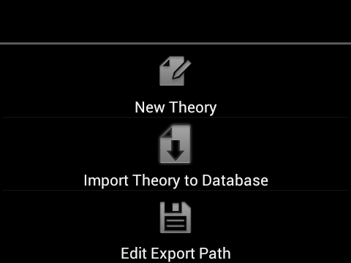
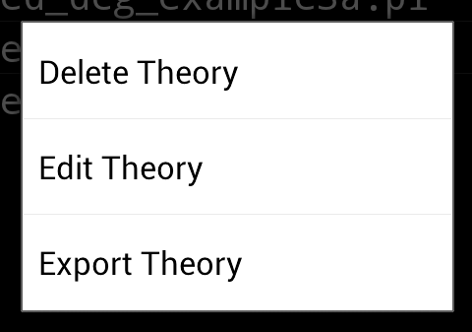
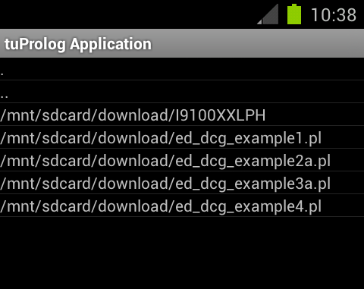
2. Theories Database Activity
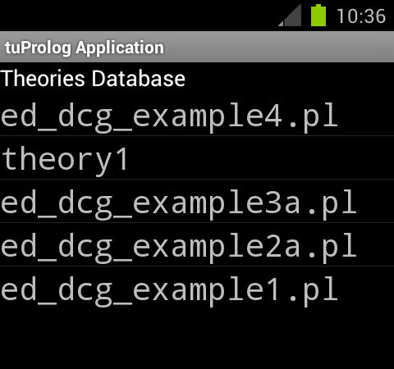

This activity shows all the theories that are loaded in the database.

To select the Theory you want you just have to click it, it will be loaded in the tuProlog engine and you will be ready to work in the Home Activity.

To add a theory to the Database from a file you have to use the menu option “Import Theory to Database”, it will open another activity that lets you browser your phone showing all the text files that you can add.
Remember that the validity check of the theory is only done when you select a theory to be loaded in the engine, that means you can have invalid theories stored in your Database.

To edit your theories you can use the ContextMenu by long clicking an entry of the Database.
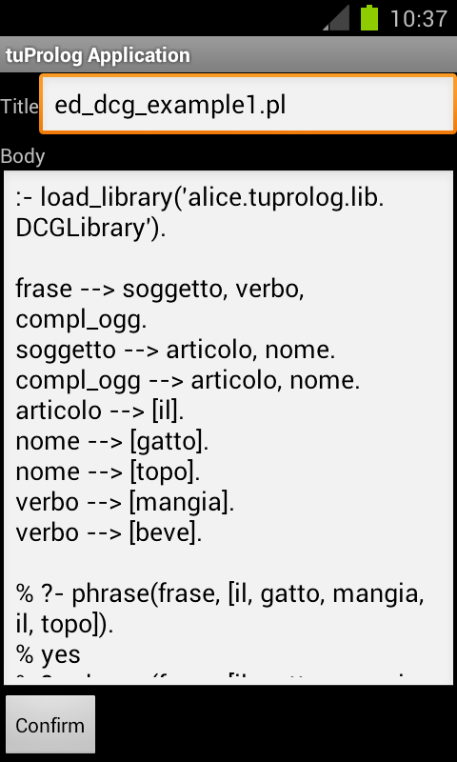
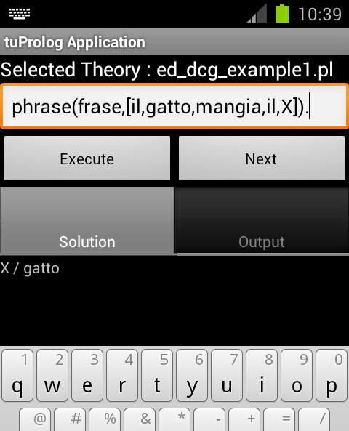
It will show you the options to Delete, Edit and Export the selected theory.
(Remember: you can change your Export Path through the “Edit Export Path” in the activity menu)

3. File Browsing Activity
This is an example of the FileBrowsing Activity, it's very simple and it only shows files that you can select to add and entry in your database.
After you successfully imported a theory, the next time you will open this activity it will start browsing from the same path, to make multiple files importing faster.

4. Edit Theory Activity

If you want to create a new theory you have to click on “New Theory” option in the menu, it will show you the Edit Theory Activity.

If you navigate to this activity from the menu option it will we empty, if you navigate here from the edit option in the context menu it will show the current body and title that you will be able to edit.

To make your changes persistent in the Database you have to click on the “Confirm” button at the end of the page, if you just press back on your phone the editing will be cancelled.

5. How to make queries
After you selected a theory from the database, it will be loaded in the tuProlog engine, to be sure of it you can check the TextView at the top of the Home Activity, if there is a problem when loading the theory you will be also warned with a Toast.
Now you just have to write your query in the input text, an auto-complete mechanism is available, which exploits the previous queries.
Pressing “Execute”, the query solution is shown in the Solution tab, along with variable bindings.
Any output performed by the application is available in the “Output” tab. If multiple solutions exist, the “Next” button can be used to browse them, along with the corresponding output.

